Introduction 2
Detailed object-oriented design 3
Class diagram 3
Changes 4
Classes/interfaces 4
Responsibilities and Collaborators 5
Bootstrap and Interaction 13
Discussion of Assignment 2 Design 15
Good Aspects 15
Missing Aspects 15
Flawed Aspects 15
Level of interpretation 16
Lessons learned 17
Domain driven design 17
Easy to maintain 17
Loosely coupling 17
Software blueprint 17
Repository pattern 18
Implementation 19
Technical details 19
Features implemented 19
Mapping from code to design 20
Platform and setup instructions 25
Demonstration 26
Scenario 1: Driver signin/signup and Admin signin/signup 26
Scenario 2: Driver book a parking slot 32
Scenario 3: Admin allocates a slot for a walk-in driver 35
Scenario 4: Admin request for statistical report 36
References 38
Appendix 39

Introduction
This document provides a comprehensive examination of the object-oriented design project focused on developing a smart parking system. Building on the groundwork of 2 previous assignments, this report serves as a complete documentation of the project's design, implementation, and execution phases.
In this assignment, we revisited and refined the initial design concepts, integrating feedback and insights gained from the previous assignments. The report provides an analysis of the design process, detailing the specific changes made to the class structures, responsibilities, and collaborations. It includes a discussion on the quality of the initial design and our reflection on the design journey we have taken.
This report also details our implementation of the design in an OOP language. The implementation phase was carefully executed to align with the refined design, ensuring that all core functionalities were accurately developed and tested. This report documents the technical aspects of the implementation, including the selection of technologies, the development environment, and the coding standards followed. At the end of the report, we provide evidence that shows our implementation works well and covers all the core requirements defined in previous assignments.

Detailed object-oriented design

Class diagram
Due to size constraints, we have made the full-sized version of this diagram available on this link: Class Diagram Detailed.jpg
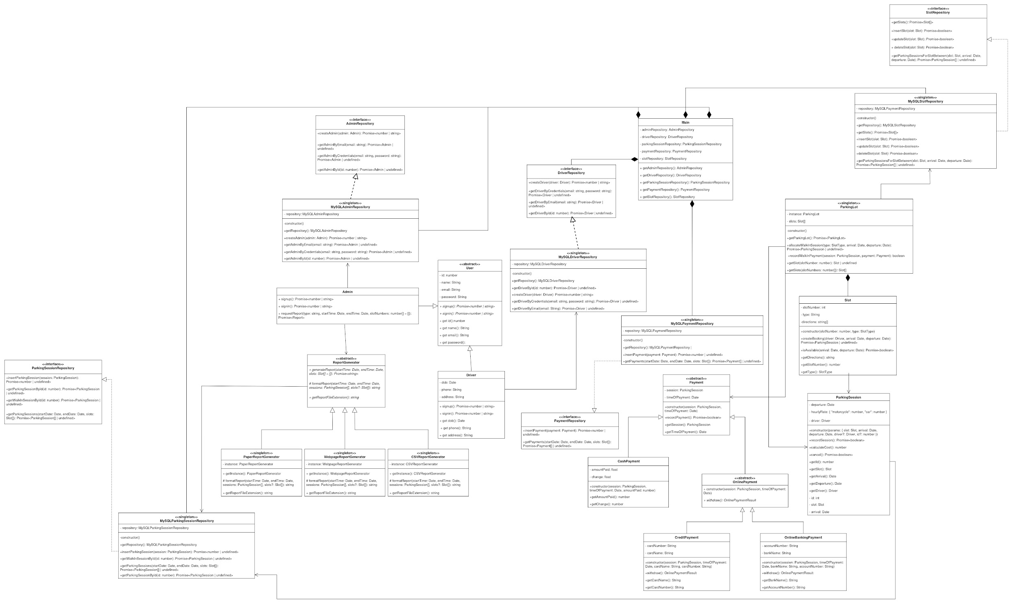
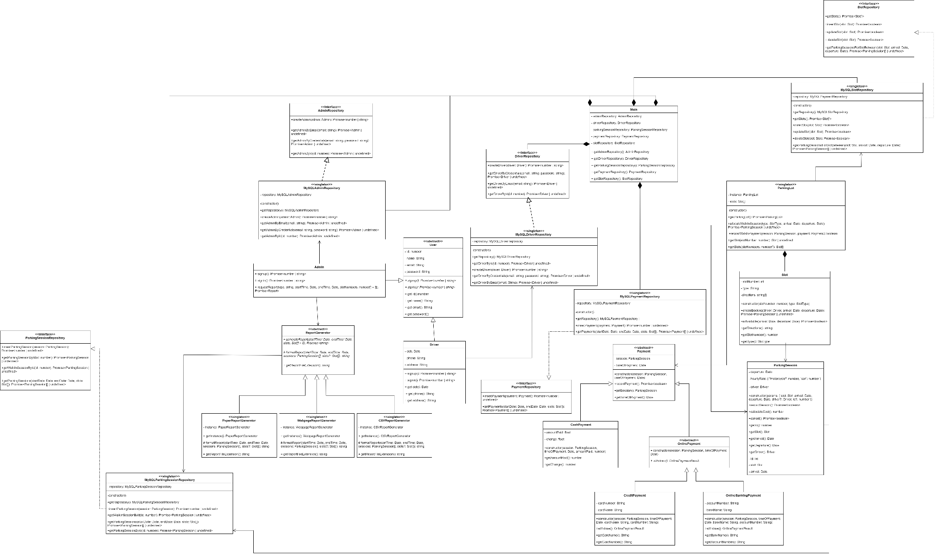
Fig 1: Final UML class diagram

Changes
We have made a number of changes to the initial class design based on the lecturer’s feedback and our reconsideration of the design. The following sections list the changes we have made categorized into class, responsibility and collaboration, and bootstrap and interaction levels.

Classes/interfaces
Here are the changes that we have made to the class list described in Assignment 2:

Classes/interfaces | Change | Classes affected | Justification
Main | Added |  | The ‘Main’ class in our system acts like a central access point and helps initialize all of the Repository classes.
AdminRepository, DriverRepository, ParkingSessionRepository, PaymentRepository, SlotRepository | Added |  | These interfaces provide a template for all of the CRUD interaction with the database layer. This interface then can be implemented by different implementation classes in order not to restrict the data storage option.
MySQLAdminRepository, MySQLDriverRepository, MySQLParkingSessionRepository, MySQLPaymentRepository, MySQLSlotRepository | Added | Admin, Driver, ParkingSession, Payment, ParkingLot | These singleton classes implement their corresponding repository interfaces to perform data retrieval and query with the MySQL database.
Invoice | Discarded | ParkingSession | The only role of the Invoice class is to wrap around a ParkingSession and calculate its cost, which seems insignificant. For that reason, we decided to remove this class and let ParkingSession calculate the parking fee by itself.
ReportData, RevenueData, FrequencyData | Discarded |  | We find that these classes do not make sense because: (1) the data for reports comes from the database, and these classes are nothing but useless wrappers for that data, and (2) the data is closely linked with and should not be separated from the report.
Report to ReportGenerator.  PaperReport to PaperReportGenerator.  WebpageReport to WebpageReportGenerator.  ExcelReport to CSVReportGenerator. | Renamed |  | The initial logic with the reporting process splits the data and representation into two classes. In addition, two different reports of the same representation would require two Report objects. After some reconsideration, we found that the old Report classes were merely data formatters, and as such they should be singletons. These classes have now been renamed to Generators and they are capable of directly fetching data for formatting.

Responsibilities and Collaborators
The following describes each class in the above diagram in detail, including their updated responsibilities in the system and collaborations with other classes.
Class name: User
Parent class(es): None
Description: An abstract class which captures the key abstractions of a User in the system. It can be specialized into 2 other classes which are Driver and Admin.
Responsibilities | Collaborators
Knows information related to a user such as name, email, etc. | None
Knows credentials related to a user. | None
Can sign up (Added) | None
Can sign in (Added) | None

Class name: Admin
Parent class(es): User
Description: This class represents an admin account. Admins can manage the parking slots as well as monitor parking statistics.
Responsibilities | Collaborators
Knows ID. | None
Can request a report based on given parameters. (Updated) | Report (Updated)
Can create a report based on the report data. (Removed) | ReportData, Report (Removed)
Can sign up (Added) | None
Can sign in (Added) | None

Class name: Driver
Parent class(es): User
Description: This class represents a driver account. Drivers can pre-book slots.
Responsibilities | Collaborators
Knows ID. | None
Knows its parking sessions. | ParkingSession
Knows its payments. | Payment
Can pre-book parking slots. | Slot, ParkingSession, OnlinePayment
Can sign up (Added) | None
Can sign in (Added) | None

Class name: ParkingLot
Parent class(es): None
Description: Represents the whole parking lot. This class acts similar to the Main class, whose responsibilities is to keep track of many aspects of the parking lot and initialize the system on startup.
Responsibilities | Collaborators
Knows its slots. | Slot
Knows its drivers. (Removed) | Driver (Removed)
Knows its admins. (Removed) | Admin (Removed)
Can modify slots’ information (Removed) | Slot (Removed)
Can create walk-in parking sessions. | ParkingSession, Payment
Can initialize the system. (Removed) | Slot, Driver, Admin (Removed)
Can find slot by id (Add) | None

Class name: Slot
Parent class(es): None
Description: This class represents a single slot in the parking lot. A slot is aware of when it is occupied.
Responsibilities | Collaborators
Knows the time intervals in which it is occupied. (Removed) | ParkingInterval (Removed)
Knows its type. | None
Knows its location. (Removed) | None (Removed)
Can check its availability for a given time period. (Changed) | ParkingInterval (Removed)  ParkingSession (Added)
Knows its number (Added) | None
Can get direction (Added) | None
Can create a booking. (Added) | Driver, ParkingSession (Added)

Class name: ParkingSession
Parent class(es): None
Description: This class represents the booking or parking session for a slot.
Responsibilities | Collaborators
Knows its slot. | Slot
Knows its parking interval. (Removed) | ParkingInterval (Removed)
Can be confirmed, which marks the chosen slot as occupied. | ParkingSessionRepository (Added)
Can be freed, which marks the chosen slot as available. | Slot
Can calculate the parking cost. | Slot (Removed)  None (Updated)
Knows its driver (Added) | Driver
Knows its arrival (Added) | None
Knows its departure (Added) | None

Class name: Payment
Parent class(es): None
Description: Abstract class for the different payment methods.
Responsibilities | Collaborators
Knows the invoice to be paid for. (Removed) | Invoice (Removed)
Knows the session (Added) | ParkingSession
Knows time of payment(Added) | None
Can record payment(Added) | None

Class name: CashPayment
Parent class(es): Payment
Description: Represents a physical cash payment made when a walk-in driver leaves the parking lot.
Responsibilities | Collaborators
Can calculate the change to return to the driver. | Invoice (Removed)
Knows the amount paid. (Added) | None
Knows the change. (Added) | None

Class name: OnlinePayment
Parent class(es): Payment
Description: An abstract class for 2 different online payment methods.
Responsibilities | Collaborators
Can withdraw a given amount of money from an external party. This method must be implemented by the subclasses. | None

Class name: CreditPayment
Parent class(es): OnlinePayment
Description: Represents a credit card payment made when a registered driver books a slot or a walk-in driver leaves the parking lot.
Responsibilities | Collaborators
Knows the details of the credit card. | None
Can withdraw from the credit card balance. Implements the withdrawal function of OnlinePayment. | None

Class name: OnlineBankingPayment
Parent class(es): OnlinePayment
Description: Represents an online banking payment made when a registered driver books a slot or a walk-in driver leaves the parking lot.
Responsibilities | Collaborators
Knows the details of the bank account. | None
Can withdraw money from the bank account balance. Implements the withdrawal function of OnlinePayment. | None

Class name: Report(Change) -> ReportGenerator
Parent class(es): None
Description: Abstract class for the different report formats.
Responsibilities | Collaborators
Knows the report data. (Removed) | ReportData (Removed)
Can fetch data needed for the report. (Added) | ParkingSessionRepository, PaymentRepository (Added)
Can format the report data into a viewable form. This method must be implemented by the subclasses. | ReportData (Change) -> ParkingSession, Payment, Slot
Knows the file extension of the output file. (Added) | None

Class name: PaperReport (Change) -> PaperReportGenerator
Parent class(es): Report (Change) -> ReportGenerator
Description: Represents the paper report format.
Responsibilities | Collaborators
Knows the report data. (Removed) | ReportData (Removed)
Can format the report data into a paper report. Implements the formatting function of Report. | ReportData (Change) -> ParkingSession, Payment, Slot
Knows the file extension of the output file. (Added) | None

Class name: ExcelReport (Change) -> CSVReportGenerator
Parent class(es): Report (Change) -> ReportGenerator
Description: Represents the CSV report format.
Responsibilities | Collaborators
Knows the report data. (Removed) | ReportData (Removed)
Can format the report data into a csv report. Implements the formatting function of Report. | ReportData (Change) -> ParkingSession, Payment, Slot
Knows the file extension of the output file. (Added) | None

Class name: PaperReport (Change) -> WebpageReportGenerator
Parent class(es): Report (Change) -> ReportGenerator
Description: Represents the webpage report format.
Responsibilities | Collaborators
Knows the report data. (Removed) | ReportData (Removed)
Can format the report data into a webpage report. Implements the formatting function of Report. | ReportData (Change) -> ParkingSession, Payment, Slot
Knows the file extension of the output file. (Added) | None

The classes below are newly added:

Class name: MySQLAdminRepository
Parent class(es): AdminRepository
Description: Implement the AdminRepository interface
Responsibilities | Collaborators
Can create Admin account | Admin
Can get the Admin information by email | None
Can get the Admin credential by email and password | None
Can get the Admin information by id | None

Class name: MySQLDriverRepository
Parent class(es): DriverRepository
Description: Implement the DriverRepository interface
Responsibilities | Collaborators
Can create Driver account | Driver
Can get the Driver information by email | None
Can get the Driver credential by email and password | None
Can get the Driver information by id | None

Class name: MySQLParkingSessionRepository
Parent class(es): ParkingSessionRepository
Description: Implement the ParkingSessionRepository interface
Responsibilities | Collaborators
Can create a ParkingSession | ParkingSession
Can get the walk in session by Id | None
Can get a list of ParkingSession | Slot
Can get a ParkingSession by id | None
Can get bookings from the Driver Id | None
Can get those sessions from the walk in session which haven’t been paid yet | None

Class name: MySQLPaymentRepository
Parent class(es): PaymentRepository
Description: Implement the PaymentRepository interface
Responsibilities | Collaborators
Can create a Payment | Payment
Can get the Payment by the drivers by Id | None
Can get a list of Payment between two given dates and/or for a given list of slots. | Slot

Class name: MySQLSlotRepository
Parent class(es): SlotRepository
Description: Implement the SlotRepository interface
Responsibilities | Collaborators
Can get information of all the slots | None
Can insert a new Slot | Slot
Can update the information of a Slot | Slot
Can delete an old Slot | Slot
Can get a list of ParkingSession which shows all of the occupied parking Slot | Slot

Bootstrap and Interaction
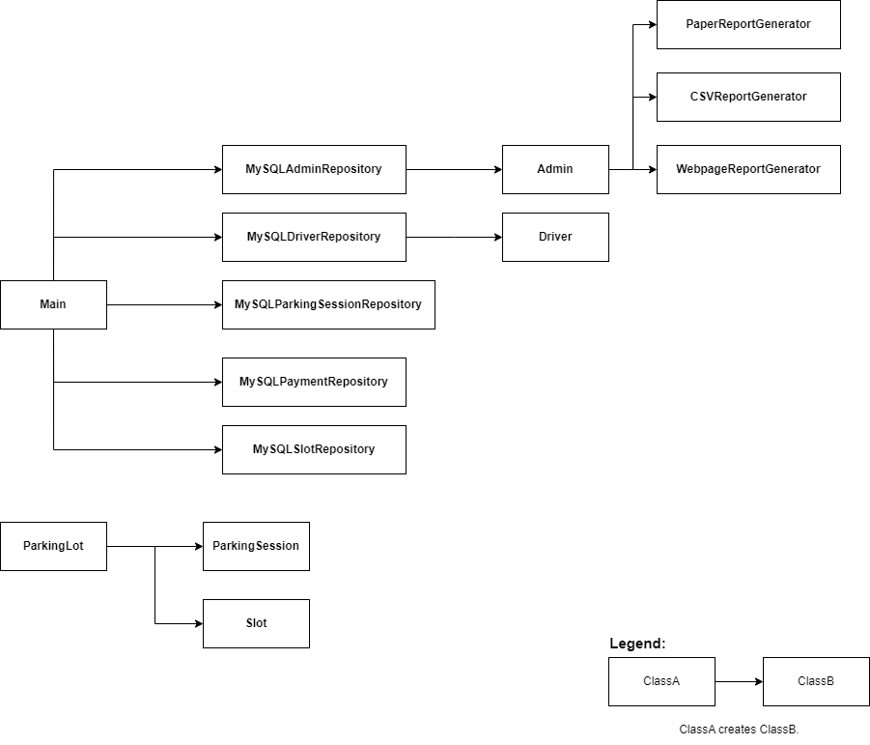
Fig 2: The updated bootstrap process of the system

Here is a brief overview of our new bootstrap process:
- We haven’t included all the classes related to Payment, namely CashPayment, CreditPayment and OnlineBankingPayment. This change happened because during the coding process, we realized that CashPayment, CreditPayment and OnlineBankingPayment can be initialized by an Express middleware. And for that reason, we don’t want to mention them in this bootstrap process diagram.
- In our new bootstrap diagram, the Main class will have the role of the central access point of the system. It holds an instance of all the singleton Repository classes. MySQLAdminRepository and MySQLDriverRepository have their own roles to create the Admin and the Driver, respectively. The admin class statically creates PaperReportGenerator, CSVReportGenerator and WebpageReportGenerator if they do not already exist.
- We also pushed ParkingLot to the left-most part of the bootstrap process since it is a singleton class that is first initialized by an Express middleware.
- ParkingSession and Slot will be created from ParkingLot and we keep this unchanged from the design in Assignment 2.

Discussion of Assignment 2 Design

Good Aspects
Comprehensive Domain Modeling:
The design successfully captured the essential entities and their relationships within the smart parking system. Classes such as User, ParkingLot, Slot, and ParkingSession accurately represent the real-world counterparts and provide a solid foundation for the system.

Use of Design Patterns:
The use of design patterns like Strategy was well-considered. The Strategy pattern allowed for different payment methods (CashPayment, CreditPayment, OnlineBankingPayment) to be implemented flexibly, enabling the system to adapt to different payment processes without altering the core logic.

Clear Separation of Concerns:
The system design clearly delineated responsibilities among classes, which helped in maintaining a clean architecture. For example, separating User responsibilities into Admin and Driver subclasses allowed for specific functionalities to be implemented distinctly, ensuring that administrative operations were isolated from user-specific actions.

Missing Aspects
The Repository pattern:
The pattern facilitated the separation of business logic and data access. This pattern was employed to manage database operations for entities like User, ParkingSession, and Payment, promoting a clean architecture.

Detailed Error Handling:
While the core functionalities were outlined, there was a lack of a strategy for error handling and input validation. Including detailed scenarios for potential errors and their corresponding handling mechanisms would enhance the system's robustness.

Flawed Aspects
Report Data and Representation Separation:
The initial decision to separate ReportData from Report representation in the design was identified as problematic. This separation was not justified and added unnecessary complexity. A more cohesive design would integrate data and representation, ensuring that reports are generated and presented more logically and efficiently.

Relationships in the Class Diagram:
The initial design exhibited some confusing or incorrect relationships among classes. There were instances of wrong or excessive relationships, which made the diagram harder to interpret and understand. Ensuring accurate and necessary relationships between classes is crucial for maintaining a clear and coherent system architecture.

Level of interpretation
Clarity and Confusion:
Overall, the initial class diagram provided a good high-level overview of the system, but some areas required additional clarification. Notably, the separation of ReportData from Report representation was confusing and seemed unnecessary, leading to potential misunderstandings about how report data is processed and displayed.

Ambiguities in Relationships:
Some relationships in the class diagram were either unclear or incorrectly represented, which complicated the interpretation of class interactions. These ambiguities necessitated further refinement and clarification to ensure the diagram accurately reflected the intended design.

Lessons learned
After finishing this course, we have been provided valuable knowledge in order to design a fully functional smart parking system from a high-level design to a technical implementation level of creating it. Looking back on this course, there are several key design principles that’re worth note taking when designing a system. Below this are some of the most important criterias:

Domain driven design
Domain-Driven Design (DDD) is a software development methodology that emphasizes the significance of prioritizing the core business domain while developing complex systems. DDD encourages tight collaboration between technical and business domains to correctly model the project. DDD favors models which are more similar in real life, hence creating a tight relationship between users and enterprises.It is also a common language used by all team members and entrepreneurs to facilitate clear communication and knowledge of the system’s target and capabilities.

Easy to maintain
The project emphasized the need for software design that is adaptable to change. Using design principles that allow for simple updates and expansions guaranteed that the system could adapt to new business demands or technological advancements without requiring large changes. This adaptable strategy helps the system remain relevant and successful over time.

Loosely coupling
Abstract classes and design patterns are critical for limiting coupling in software design. Abstract classes let developers build shared interfaces and functionality in a base class that can be inherited and customized by subclasses. This centralisation of essential functionality means that changes in one subclass have little influence on the others, resulting in more maintainable code. By using observer,strategy or factory design patterns can further loosen the relationship between different classes.

Software blueprint
A software blueprint, which includes thorough documentation, flowcharts, data models, a class diagram, and an ER diagram, is critical for understanding system behavior and data flow. Spending time on this design allows the team to eliminate uncertainty and assumptions later on, resulting in a more accurate and successful implementation.

Repository pattern
The Repository pattern is a design pattern that isolates data access functionality while providing a clean API to the business logic layer. It isolates the business logic from the data access code, making it easier to maintain and test by centralizing data retrieval and manipulation techniques. This pattern facilitates the construction of dummy repositories for testing and ensures that data access functionality evolves independently of the rest of the application. By doing so, we can provide a set of rules that all of the repository classes that implement that interface must follow. By doing so, we can make our system more flexible to change the data storage.

Implementation

Technical details
Our group’s implementation of this design is a full-stack web application. We have chosen TypeScript as our programming language for the backend as it is very conducive to web development while also bearing the characteristics of an object-oriented language. This allows us to write code for the domain classes that closely matches the class design. In addition, the backend has been implemented as a RESTful API with Express.js. Each key function of the application is made possible with a combination of one or more Express routes. These Express routes and their corresponding middlewares are responsible for instantiating some of the classes.
For the frontend, we have decided that JavaScript with the Vue.js framework will be enough because we want to focus more on the object-oriented aspect of the backend. For data persistence, we have chosen a MySQL database running on localhost.
During development, we tried our best to follow the TypeScript coding standard set by Google (Google TypeScript Style Guide, n.d.). That said, due to the time constraints, there may be some deviations in certain parts of the code.

Features implemented
Due to time limitations, our team has not been able to develop all of the 10 functional requirements specified in the Requirements Specification (see Appendix). We have only been able to implement 6/10 requirements, which are:
Task 1.1 - Create driver account
Task 1.3 - Pre-book a parking slot
Task 1.5 - Park vehicle
Task 1.6 - Pay for booking
Task 1.7 - Pay for walk-in
Task 2.1 - View booking statistics of the parking lot
However, we have decided that these tasks are enough as they form the core functionality of the application. The other four tasks, which are:
Task 1.2 - Update driver account,
Task 1.4 - Change a booked slot,
Task 2.2 - Change existing parking slot,
Task 2.3 - Add a new parking slot,
are relatively minor and can be implemented with a few simple inserts and updates to the database.
For simplification, we have also abstracted away a number of technical features such as performing bank transactions or providing detailed directions to a given parking slot. To account for these missing features, we have the program return a short message to the user.

Mapping from code to design
Class name | Class implementation | Responsibility
User | signUp: An abstract function which will be implemented by Admin and Driver. It will be used to sign up an account. | Can sign up
User | signIn: An abstract function which will be implemented by Admin and Driver. It will be used to sign in an account. | Can sign in
Admin | signUp: It is an implementation from the User class. It will call the repository of Admin in order to create a new admin account. It will also verify if the email has been used before or not. | Can sign up
Admin | signIn: It is also an implementation which logs the user in the system by checking if the email and password is correct or not. | Can sign in
Admin | requestReport: It will generate the report through start, end time, slot and report type. It returns a Report. | Can request a report based on given parameters.
Driver | signUp: It is an implementation from the User class. It will call the repository of Driver in order to create a new Driver account. It will also verify if the email has been used before or not. | Can sign up
Driver | signIn: It is also an implementation which logs the user in the system by checking if the email and password is correct or not. | Can sign in
ParkingLot | getParkingLot: Call the SlotRepository to return a ParkingLot instance | Can return a parking lot object
ParkingLot | allocateWalkInSession: Create a ParkingSession based on the slot type, arrival and departure time then record it. | Can create walk-in parking sessions.
ParkingLot | getSlot: Return a slot based on the slot number | Can find slot by id
ParkingLot | getSlots: Return a list of slots | Can find slot by id
ParkingSession | recordSession: Call the parking session repository then insert a parking session to it. Return a boolean to check whenever the operation is successful or not. | Can be confirmed, which marks the chosen slot as occupied.
ParkingSession | calculateCost: Return the parking fee based on the departure and arrival time in this class. | Can calculate the parking cost.
ParkingSession | cancel: do cancelation for this operation. | Can be freed, which marks the chosen slot as available.
Slot | createBooking: It checks the availability of a slot then creates a new ParkingSession to record it if the slot is vacant. | Can create a booking.
Slot | isAvailable: This calls the SlotRepository to check the session if it’s available or not. This function returns a boolean. | Can check its availability for a given time period.
Slot | getDirections: This function returns a string for the direction to the slot. | Can get direction
Payment | recordPayment: It calls the PaymentRepository to insert a Payment. | Can record payment
CashPayment | Note: This class only returns the amount paid and changes. | Can calculate the change to return to the driver.
OnlinePayment | withDraw: An abstract function which will be implemented in the 2 online payment functions. | Can withdraw a given amount of money from an external party. This method must be implemented by the subclasses.
CreditPayment | withDraw: Implement the withDraw abstract function in the OnlinePayment class, It returns an OnlinePaymentResult. | Can withdraw from the credit card balance. Implements the withdrawal function of OnlinePayment.
OnlineBankingPayment | withDraw: Implement the withDraw abstract function in the OnlinePayment class, It returns an OnlinePaymentResult. | Can withdraw money from the bank account balance. Implements the withdrawal function of OnlinePayment.
ReportGenerator | generateReport: This function calls the ParkingSessionRepository to get those ParkingSession to create a report. | Can fetch data needed for the report.
ReportGenerator | formatReport: This abstract function will return a string for the format of the report. | Can format the report data into a viewable form. This method must be implemented by the subclasses.
ReportGenerator | getReportFileExtension: This abstract function will return a string for the report file extension. | Knows the file extension of the output file.
CSVReportGenerator | formatReport: Implement the function in the parent abstract class, It runs 2 loops to get the output which consists of slotNumber, Type, bookingCount and revenue. | Can format the report data into a csv report. Implements the formatting function of Report.
CSVReportGenerator | getReportFileExtension: This function returns a string for the file extension name. In this case, It is a CSV so It returns “.csv” file format. | Knows the file extension of the output file.
PaperReportGenerator | formatReport: Implement the function in the parent abstract class, It runs 2 loops to get the output which consists of slotNumber, Type, bookingCount and revenue. | Can format the report data into a paper report. Implements the formatting function of Report.
PaperReportGenerator | getReportFileExtension: This function returns a string for the file extension name. In this case, It is a text file so It returns “.txt” file format. | Knows the file extension of the output file.
WebpageReportGenerator | formatReport: Implement the function in the parent abstract class, It maps the outSlotNumber to multiple table rows. It runs a loop to calculate the booking count, total revenue and slot type. It returns a website with a table formatted in HTML format. | Can format the report data into a webpage report. Implements the formatting function of Report.
WebpageReportGenerator | getReportFileExtension: This function returns a string for the file extension name. In this case, It is a web page so It returns “.html” file format. | Knows the file extension of the output file.
MySQLAdminRepository | createAdmin: It runs the SQL in order to insert the Admin class into the database with the information of Name, Email, Password. | Can create Admin account
MySQLAdminRepository | getAdminByEmail: It runs the SQL in order to find an Admin by a String input. | Can get the Admin information by email
MySQLAdminRepository | getAdminByCredentials: It runs the SQL in order to get the information of the Admin for the SignIn. | Can get the Admin credential by email and password
MySQLAdminRepository | getAdminById: It runs the SQL in order to find the Admin by a Number input. | Can get the Admin information by id
MySQLDriverRepository | createDriver: It runs the SQL in order to insert the Driver class into the database with the information of Name, Email, Password, DOB, Phone, Address | Can create Driver account
MySQLDriverRepository | getDriverByEmail: It runs the SQL in order to find a Driver by a String input. | Can get the Driver information by email
MySQLDriverRepository | getDriverByCredentials: It runs the SQL in order to get the information of the Driver for the SignIn. | Can get the Driver credential by email and password
MySQLDriverRepository | getDriverById: It runs the SQL in order to find the Driver by a Number input. | Can get the Driver information by id
MySQLParkingSessionRepository | insertParkingSession: It creates a ParkingSession into the database through a ParkingSession object. | Can create a ParkingSession
MySQLParkingSessionRepository | getWalkInSessionById: It returns a newParkingSession if the ParkingSession hasn’t been created yet. | Can get the walk in session by Id
MySQLParkingSessionRepository | getParkingSession: It returns a ParkingSession list of which are found. | Can get a list of ParkingSession
MySQLParkingSessionRepository | getParkingSessionById: It returns a ParkingSession object through a search by Id. | Can get a ParkingSession by id
MySQLPaymentRepository | insertPayment: It inserts the Payment object into the database then it returns the Payment’s session Id. | Can create a Payment
MySQLPaymentRepository | getPayments: It searches for the Payment by StartDate, EndDate and a list of Slot. It runs the SQL to return a list of Payment objects. | Can get a list of Payment between two given dates and/or for a given list of slots.
MySQLSlotRepository | getSlots: It returns all the Slots existing by a list of Slot objects. | Can get information of all the slots
MySQLSlotRepository | insertSlot: It inserts a Slot object into the SQL database. Returning a boolean to check whenever the operation is successful or not. | Can insert a new Slot
MySQLSlotRepository | updateSlot: It updates a Slot object from the SQL database. Returning a boolean to check whenever the operation is successful or not. | Can update the information of a Slot
MySQLSlotRepository | deleteSlot: It deletes a Slot object from the SQL database. Returning a boolean to check whenever the operation is successful or not. | Can delete an old Slot
MySQLSlotRepository | getParkingSessionsForSlotBetween: It returns a list of ParkingSession objects through the inputs of Slot, ArrivalDate and DepartureDate. | Can get a list of ParkingSession which shows all of the occupied parking Slot

Platform and setup instructions
This application has been developed mainly on Windows 11 using Visual Studio Code. It uses npm as the package manager and runs on Node v20.11.1 (although later versions will still work.) It requires a local MySQL server to function.
For those interested in running the application, the source code is available on this GitHub repository: https://github.com/pine04/smartparking. Follow these steps to get the application up and running on your machine:
- The application requires Node.js and MySQL to run. Please follow the instructions provided on their official websites to install them on your machine.
- Clone the code from the GitHub repository using:
git clone https://github.com/pine04/smartparking.git
- After cloning, navigate to the frontend and backend directories and run npm i in each to install all the dependencies to your local machine.
- Navigate to the backend directory and import the database.sql code to your local SQL database. After that, navigate to backend/services and modify mysql_pools.ts to match your database credentials.
- Run npm install -g typescript to install the Typescript compiler globally. After that, navigate to the backend folder and run npm run compile in the command prompt. A folder name dist will appear. Run npm start to start the backend server.
- Navigate back to the frontend folder. Use npm run dev to start the frontend server and the website is ready to be used at port 5173 with the URL http://localhost:5173/

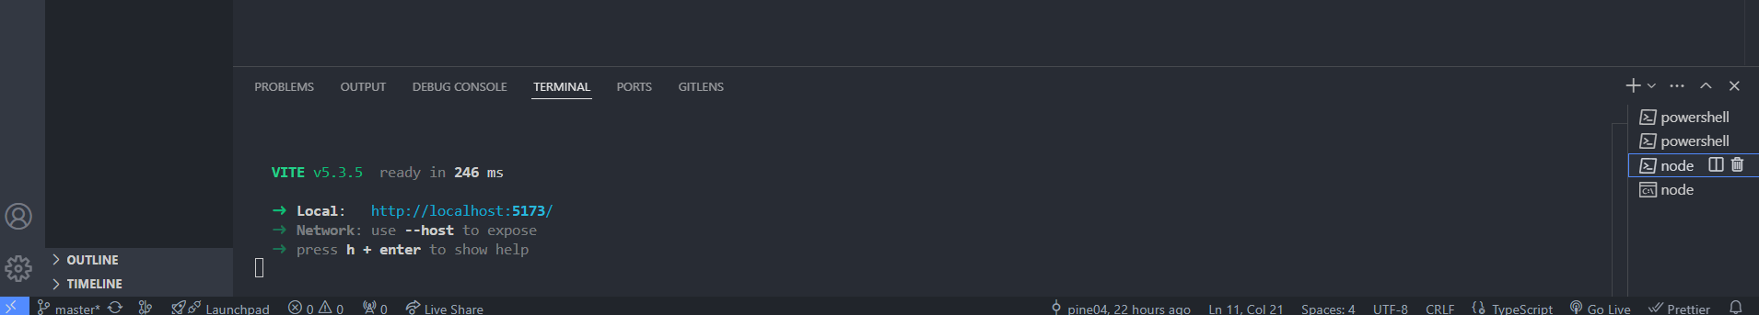
Fig 3: Successful execution of frontend

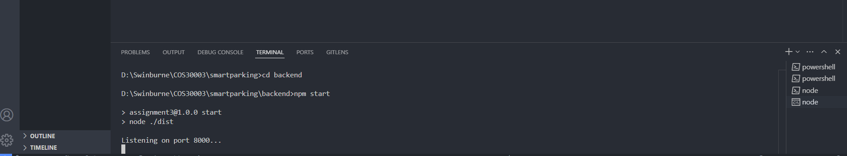
Fig 4: Successful execution of backend

Demonstration
The following section shows several scenarios of a user interacting with the application to carry out key tasks. A video demonstration of these scenarios is available on this Google Drive link.

Scenario 1: Driver signin/signup and Admin signin/signup
The user types in their information to signup/login as we can see on Fig 5,6,7,8. If there are any errors with their input, the error message will pop up as shown in Fig 9. After successfully logging into the system. A home screen will display to show the dashboard of the driver or admin as we can see on Fig 10 and Fig 11.
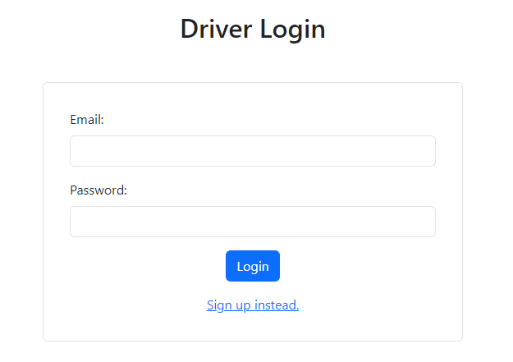

Fig 5: Driver login form

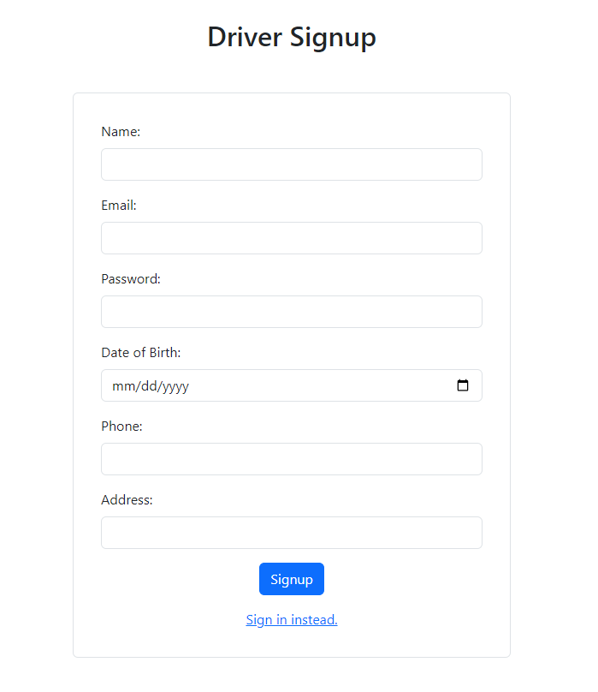
Fig 6: Driver signup form
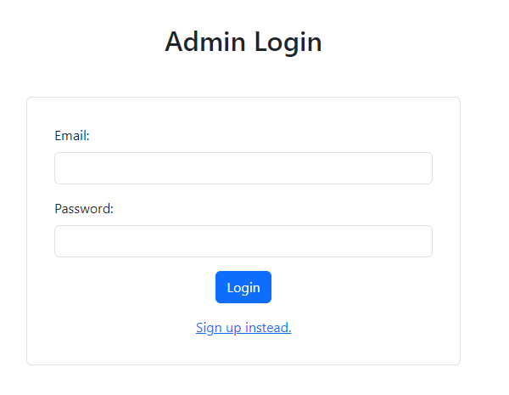

Fig 7: Admin login form
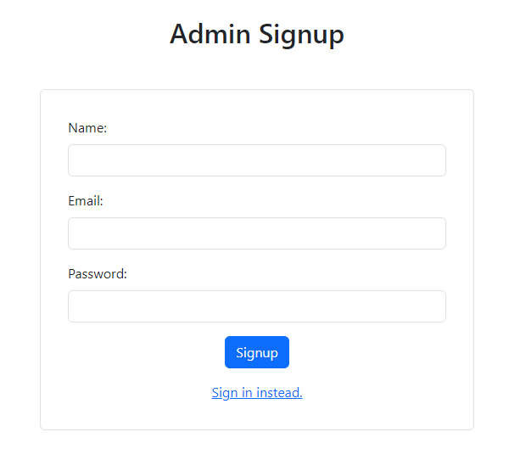

Fig 8: Admin signup form

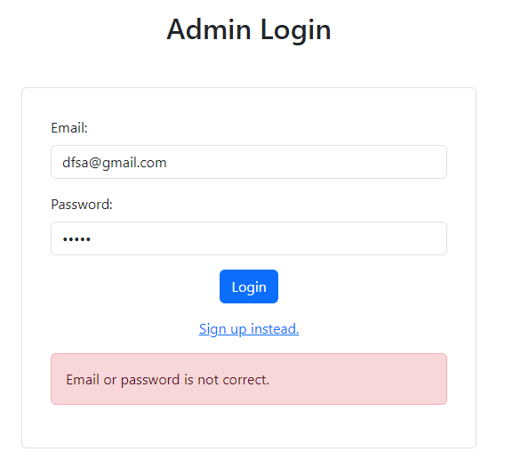
Fig 9: Form validation for admin login

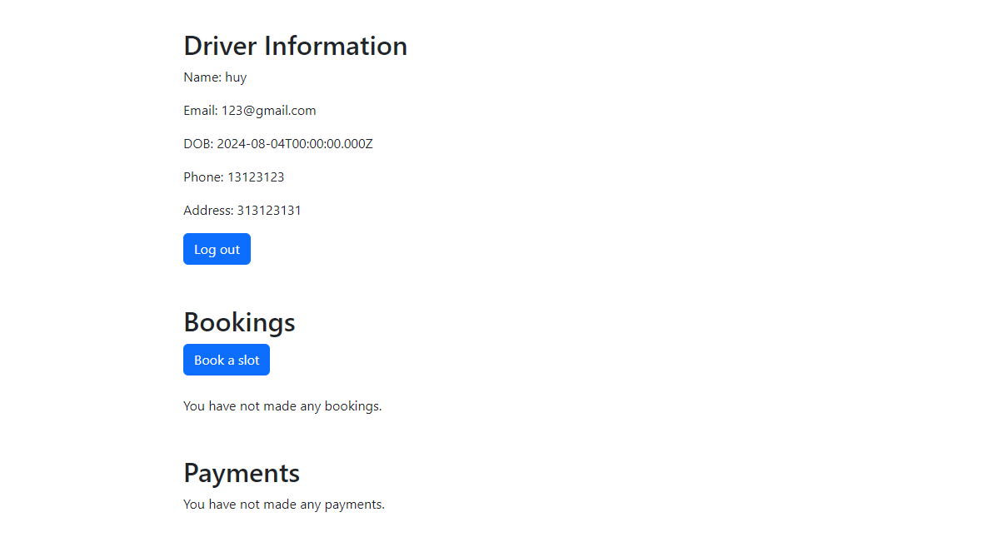
Fig 10: Driver dashboard
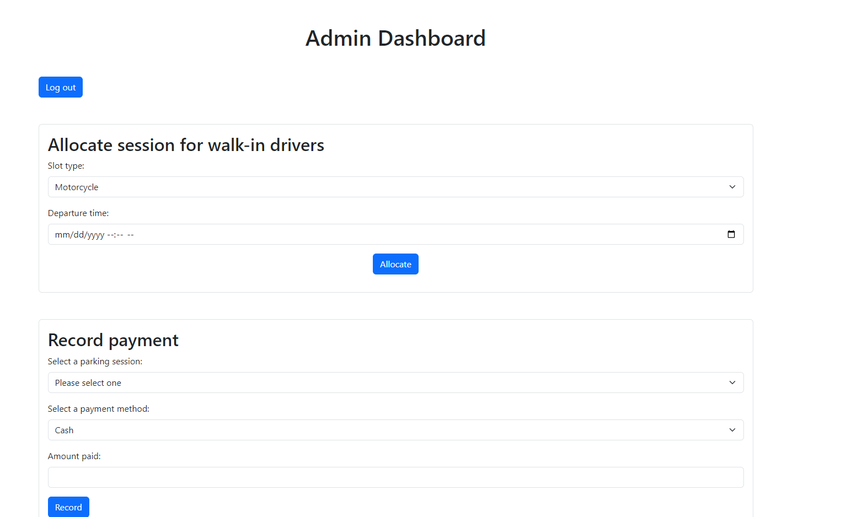
Fig 11: Admin dashboard

Scenario 2: Driver book a parking slot
To perform a booking, the driver must already have an account and is already logged into the system. On the dashboard screen, the user can navigate to the booking form by clicking on the ‘book a slot’ button as shown in Fig 12. After that, the driver will have access to the booking page as shown in Fig 13. Once the driver has completed filling out the form, they can proceed to the payment process. Fig 14 shows the payment form that the driver needs to fill in their payment information before a message indicates that the user has successfully performed the payment. If the driver clicks the link to go back to the dashboard, the dashboard will display the updated bookings and payments as we can see in Fig 16.
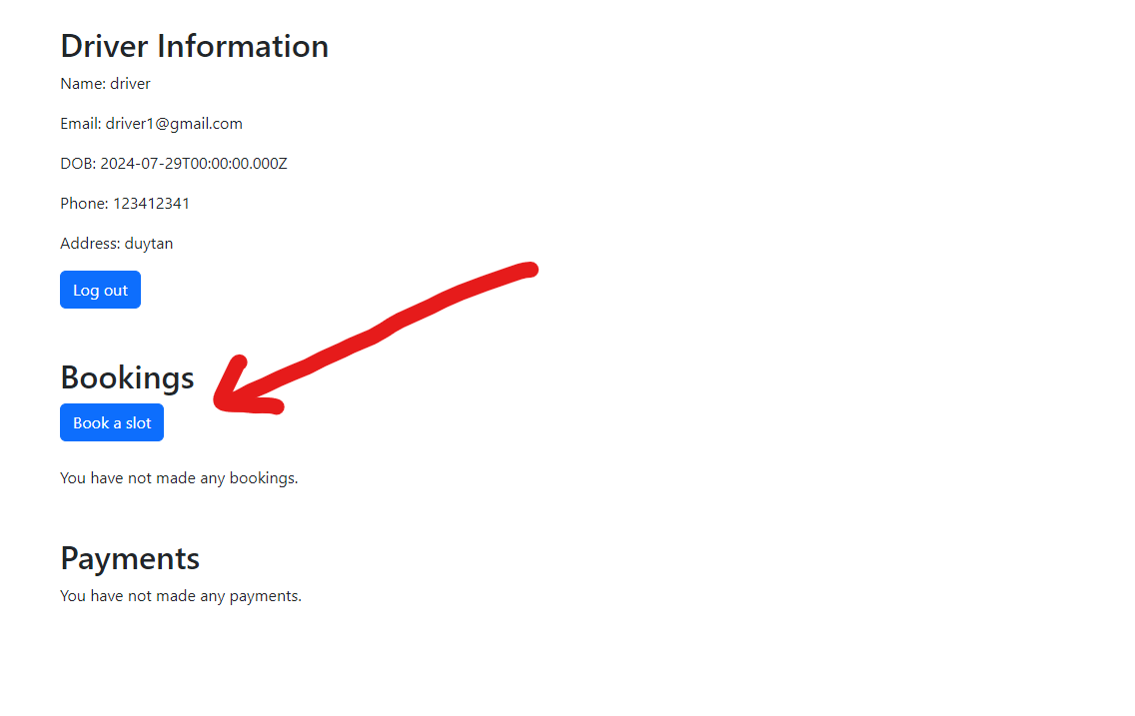
Fig 12: Driver click the ‘book a slot’ button
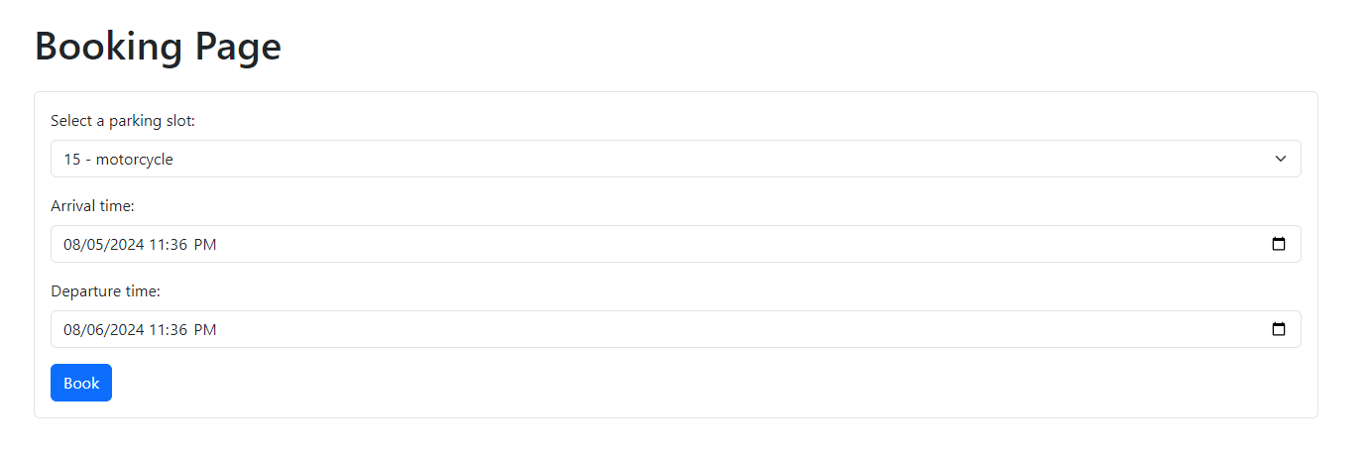
Fig 13: The driver must fill out the form to perform a booking
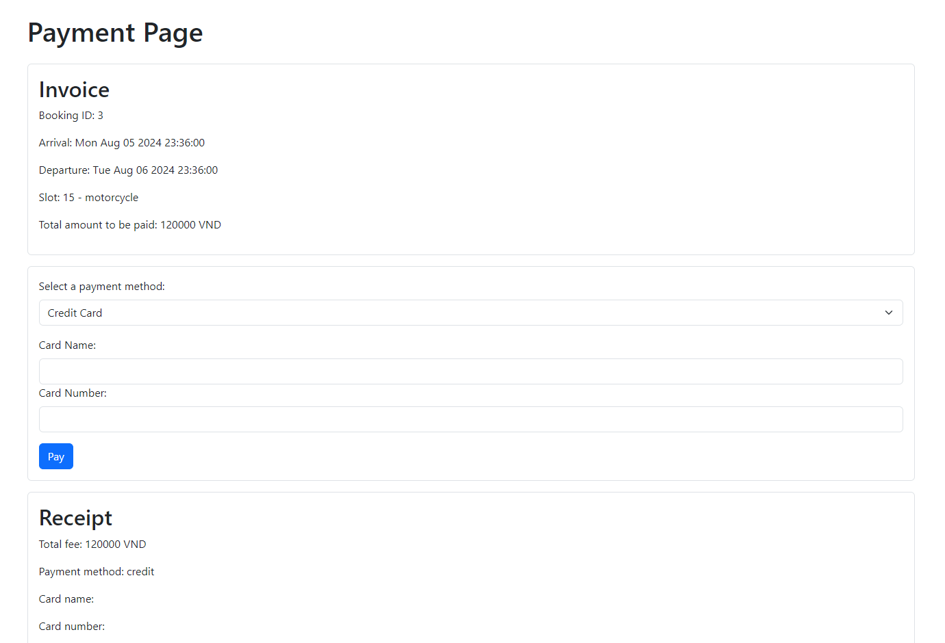
Fig 14: The payment form that the driver need to fill

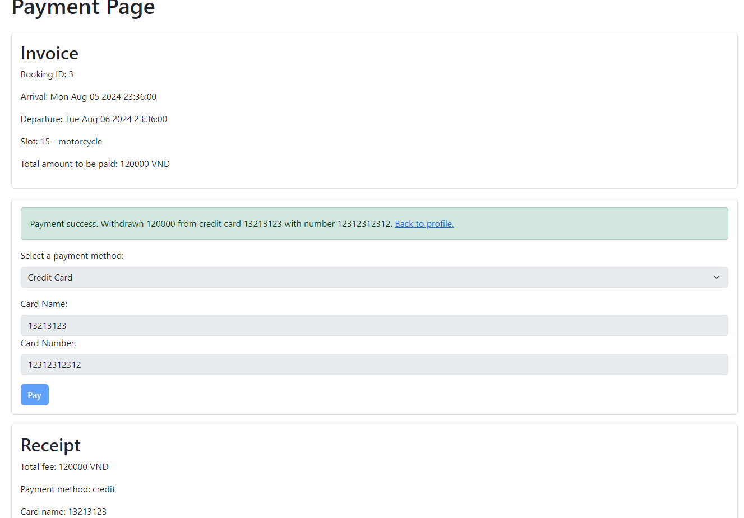
Fig 15: A success message indicate that the user have completed the transaction
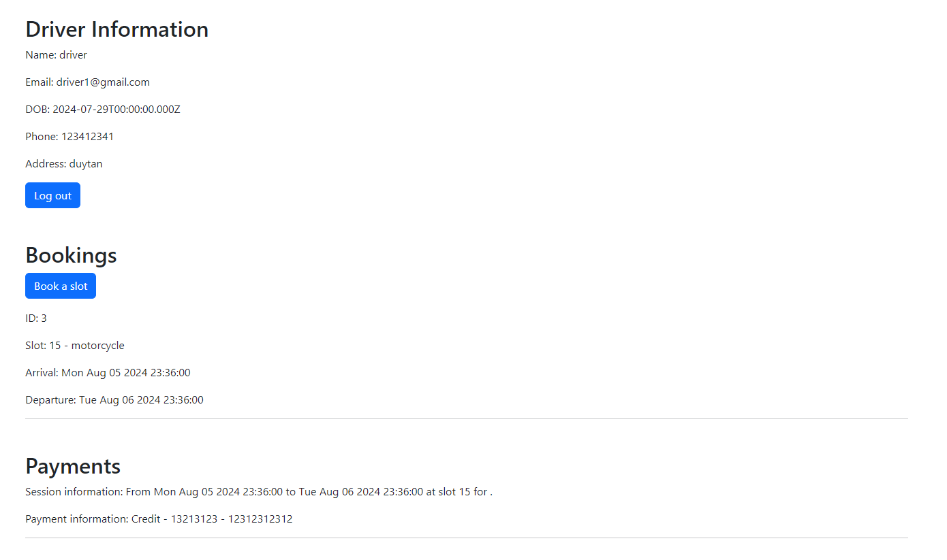
Fig 16: Updated driver dashboard

Scenario 3: Admin allocates a slot for a walk-in driver
In order to perform session allocation for walk-in drivers, the admin must be inside the system first. As shown in Fig 17, the user has to fill in the form to allocate a session for walk-in first. After filling out all of the basic information and clicking the ‘allocate’ button, A success message will be displayed and the parking session can be selected in the record payment section. After the walk-in driver has completed the data for the transaction and the ‘Record’ button is clicked, a success message will be displayed as shown in Fig 18 and the slot allocation is done.
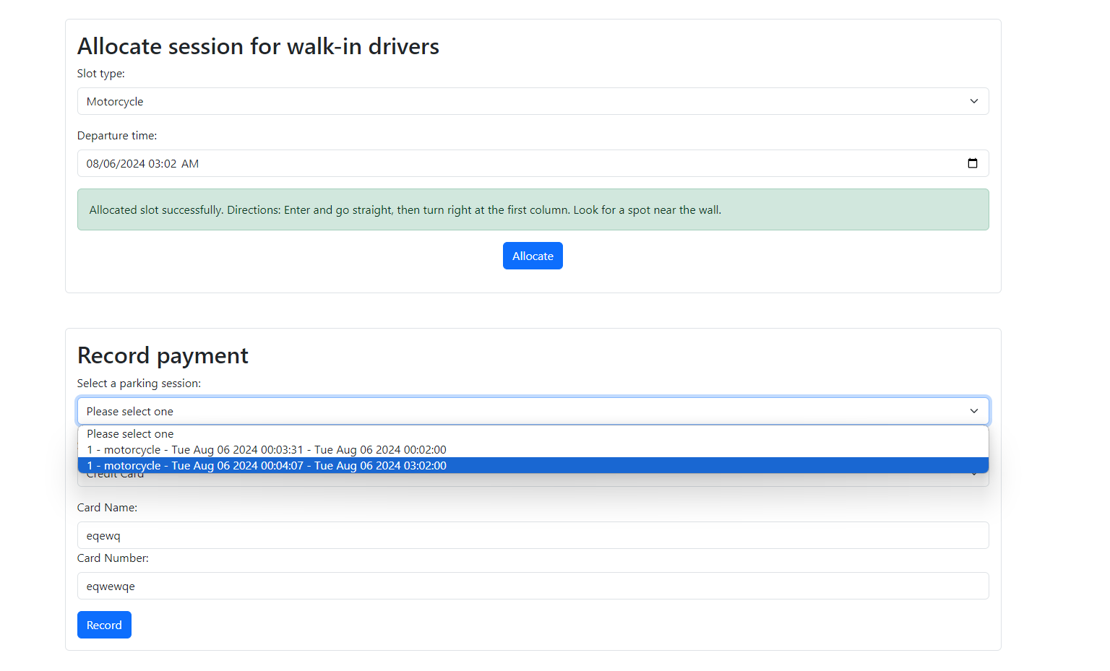
Fig 17: Form for session allocation
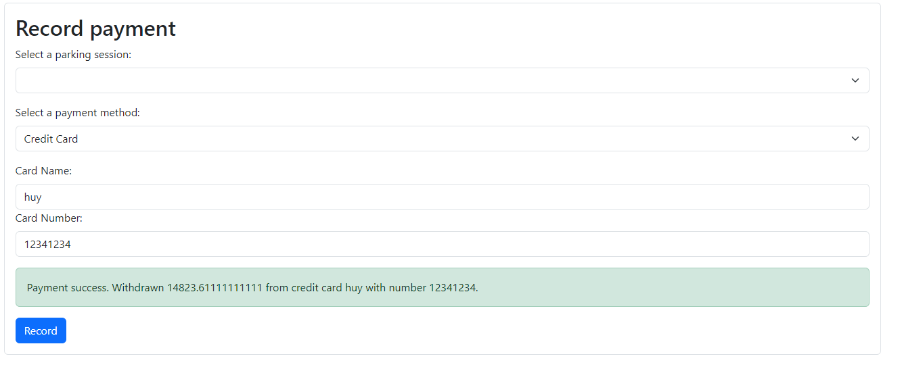
Fig 18: A success message showing that the payment has been made

Scenario 4: Admin request for statistical report
To request a statistical report, the admin will have to log in to the system. When the admin navigates to the bottom of the dashboard page, there will be a form for the admin to request the statistical report (Fig 19). Admin may need to fill out the form to get the statistics that they want to look into. There will be 3 kinds of reports that the admin may be interested in, including web page reports, CSV reports, or paper reports. Based on the choice of the admin, the system will output the corresponding report including all of the information.
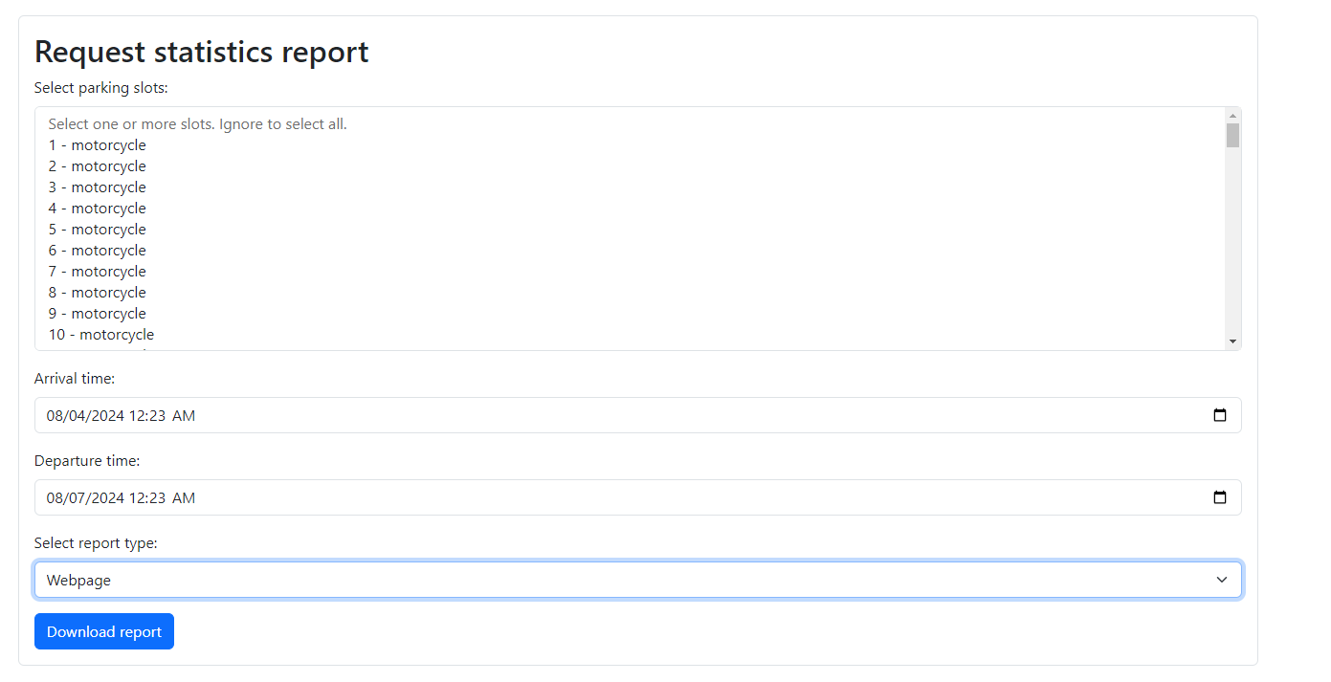
Fig 19: Form for admin to request statistic report
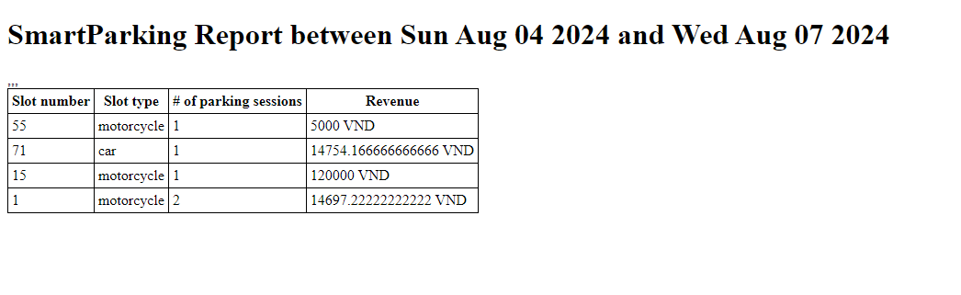
Fig 20: Webpage statistic report
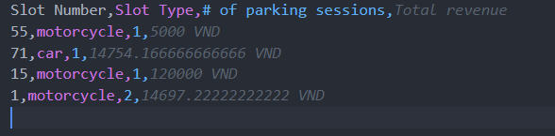
Fig 21: CSV statistic report

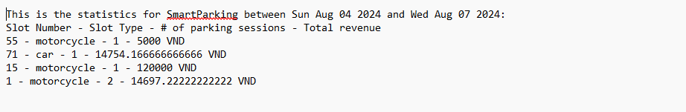
Fig 22: Paper statistic report

References
Google TypeScript Style Guide. (n.d.). Google. Retrieved August 6, 2024, from https://google.github.io/styleguide/tsguide.html

Appendix
Attached on the remainder of the pages is the Assignment 2 report that this document was based on.

